# Test Cases

# Post Request :

Url : <http://localhost:8080/user>

Data:

{

  "userName":"aman13",

  "firstName":"aman",

  "lastName":"yadav",

  "emailID":"aman@1234",

  "address1":"lucknow",

  "mobileNumber":"1234547610",

  "address2":"lko"

}

If :

1. mobile number not equal to 10 digit
2. emailId not include @
3. userName ,emailID,mobileNumber is NULL or already associated with any user.
4. Address1 and Address2 both are NULL
5. firstName or lastName are NULL

in All above cases data will not be created.

# Get Request :

Url : [http://localhost:8080/user?userId=<userID](http://localhost:8080/user?userId=%3cuserID)>

If :

a)user Id is invalid or not exist then error message will be show.

otherwise :

user First Name ,last Name ,mobile Number ,email Id will show.

Eg.

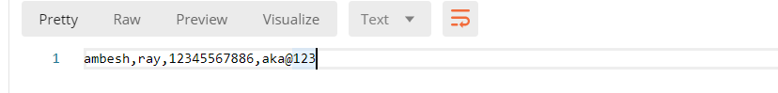

# Put Request :

Url : [http://localhost:8080/user?userId=<userID](http://localhost:8080/user?userId=%3cuserID)>

If :

a) user Id is invalid or not exist then error message will show.

b) if username is not null ,i.e user want to update username .first check enter username is exist or not

i) if it exist then data will not update.

ii) if not exist then further step will check.

c) if emailId is not null ,i.e user want to update email Id .first check enter email Id is exist or not

i) if it exist then data will not update.

ii) if not exist then further step will check.

d) if mobile number is not null ,i.e user want to update mobile number.first check enter mobile number is exist or not

i) if it exist then data will not update.

ii) if not exist then further step will check.

e)If above steps are right then update user data which input value are not null.

Data Format:

Data:

{

  "userName":"aman13",

  "firstName":"aman",

  "lastName":"yadav",

  "emailID":"aman@1234",

  "address1":"lucknow",

  "mobileNumber":"1234547610",

  "address2":"lko"

}

# Delete Request:

Url : [http://localhost:8080/user?userId=<userID](http://localhost:8080/user?userId=%3cuserID)>

If :

a) user Id is invalid or not exist then error message will show.

**Otherwise :**

Data will deleted.